SRS Document Development and GitHub

Jonathan Schaub

The University of Arizona Global Campus

CST 499 Capstone for Computer Software Technology

Dr. Charmelia Butler

October 23, 2023
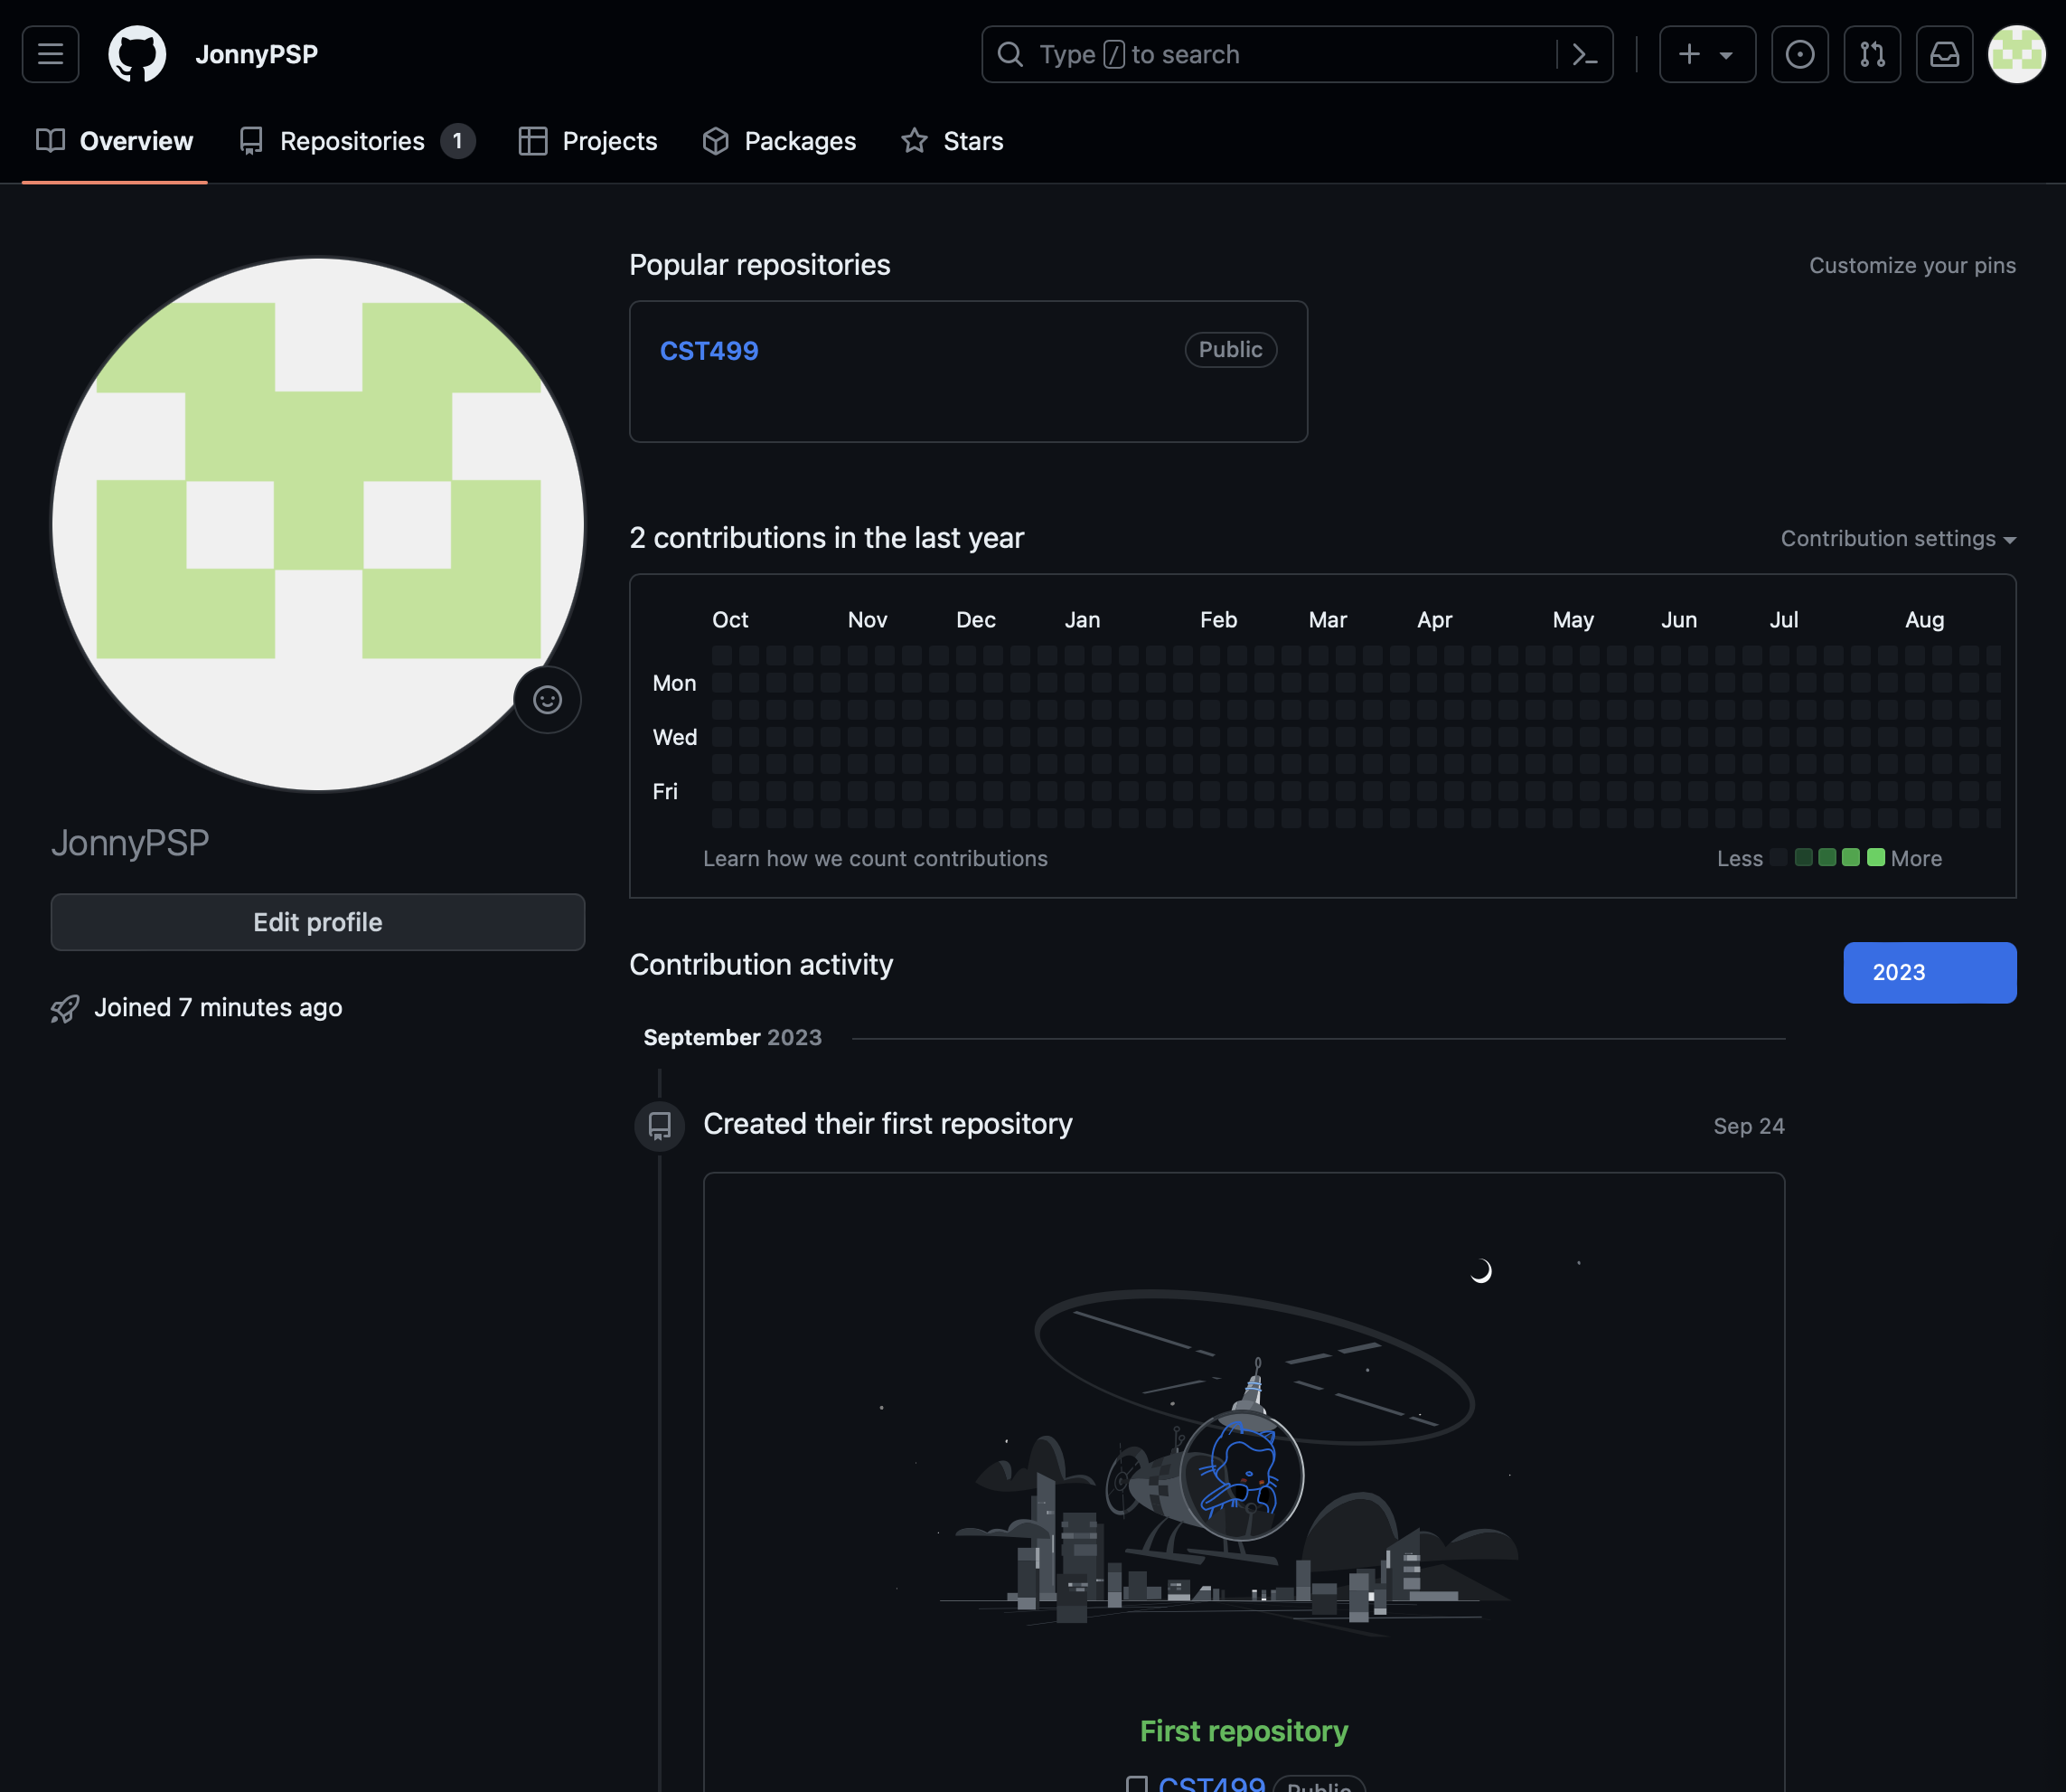
https://github.com/JonnyPSP/CST499
https://github.com/JonnyPSP

Software Requirements Specification
for
Student and Course Registration System
Version 1.0 approved
Prepared by Jonathan Schaub
University of Arizona Global Campus
September 24, 2023
Table of Contents
Table of Contents ii
Revision History ii
1. Introduction 1
1.1 Purpose 1
1.2 Document Conventions 1
1.3 Intended Audience and Reading Suggestions 1
1.4 Product Scope 1
1.5 References 1
2. Overall Description 2
2.1 Product Perspective 2
2.2 Product Functions 2
2.3 User Classes and Characteristics 2
2.4 Operating Environment 2
2.5 Design and Implementation Constraints 2
2.6 User Documentation 2
2.7 Assumptions and Dependencies 3
3. External Interface Requirements 3
3.1 User Interfaces 3
3.2 Hardware Interfaces 3
3.3 Software Interfaces 3
3.4 Communications Interfaces 3
4. System Features 4
4.1 System Feature 1 4
4.2 System Feature 2 (and so on) 4
5. Other Nonfunctional Requirements 4
5.1 Performance Requirements 4
5.2 Safety Requirements 5
5.3 Security Requirements 5
5.4 Software Quality Attributes 5
5.5 Business Rules 5
6. Other Requirements 5
Appendix A: Glossary 5
Appendix B: Analysis Models 5
Appendix C: To Be Determined List 6

Revision History
Name | Date | Reason For Changes | Version

Introduction

Purpose
The purpose of this document is to outline software requirements for the development of an online Student and Course Registration System. The purpose of this system is to facilitate enrollment of students online in their courses.

Document Conventions
<Describe any standards or typographical conventions that were followed when writing this SRS, such as fonts or highlighting that have special significance. For example, state whether priorities for higher-level requirements are assumed to be inherited by detailed requirements, or whether every requirement statement is to have its own priority.>

Intended Audience and Reading Suggestions
Developers - To understand the software functionalities and constraints.
Project Managers - To plan and monitor the project.
Testers - For creating test cases and validation.
End-User - To understand system capabilities.

Product Scope
The scope of this software system is to provide a system that allows users to register, login, enlist in in courses, as well as course management in the form of adding and removing courses from a roster.

References
Mayo, R. F., Villanueva, A. T., Ortiz, K. A. B., Reyes, A. C. M., Payad, J. J. S., Rodriguez, R. L., & Serrano, E. A. (2022). Web-Based Enrollment System for Public Junior High School in the Philippines: A Case Study in the Province of Cavite Public Schools. 2022 2nd International Conference in Information and Computing Research (ICORE), Information and Computing Research (ICORE), 2022 2nd International Conference in, ICORE, 134–138. https://doi.org/10.1109/iCORE58172.2022.00044
Singh R, Singh R, Kaur H, Gupta O. P. (2016) Development of Online Student Course Registration System. Orient.J. Comp. Sci. and Technol;9(2). Available from: http://www.computerscijournal.org/?p=3682
Tsui, F., Karam, O., & Bernal, B. (2018). Essentials of software engineering (4th ed.). Jones & Bartlett Learning.

Overall Description

Product Perspective
<Describe the context and origin of the product being specified in this SRS. For example, state whether this product is a follow-on member of a product family, a replacement for certain existing systems, or a new, self-contained product. If the SRS defines a component of a larger system, relate the requirements of the larger system to the functionality of this software and identify interfaces between the two. A simple diagram that shows the major components of the overall system, subsystem interconnections, and external interfaces can be helpful.>

Product Functions
The functions of this system include:
User Registration
User Authentication
Couse Enrollment
Course Listing
Course Cancellation

User Classes and Characteristics
Students
Administrators
IT Staff

Operating Environment
Current browsers like Chrome, Firefox, Safari, etc., that operate on operating systems like Windows, MacOS, Linux (Singh, et al., 2016).

Design and Implementation Constraints
<Describe any items or issues that will limit the options available to the developers. These might include: corporate or regulatory policies; hardware limitations (timing requirements, memory requirements); interfaces to other applications; specific technologies, tools, and databases to be used; parallel operations; language requirements; communications protocols; security considerations; design conventions or programming standards (for example, if the customer’s organization will be responsible for maintaining the delivered software).>

User Documentation
<List the user documentation components (such as user manuals, on-line help, and tutorials) that will be delivered along with the software. Identify any known user documentation delivery formats or standards.>

Assumptions and Dependencies
<List any assumed factors (as opposed to known facts) that could affect the requirements stated in the SRS. These could include third-party or commercial components that you plan to use, issues around the development or operating environment, or constraints. The project could be affected if these assumptions are incorrect, are not shared, or change. Also identify any dependencies the project has on external factors, such as software components that you intend to reuse from another project, unless they are already documented elsewhere (for example, in the vision and scope document or the project plan).>

External Interface Requirements

User Interfaces
The user interfaces of the online Student and Class Registration System (SCRS) should be user-friendly and intuitive, as well as responsive.

Hardware Interfaces
Servers hosting the SCRS and other related databases.

Software Interfaces
MySQL for RDBMS management, PHP, XAMPP (Singh, et al., 2016)

Communications Interfaces
<Describe the requirements associated with any communications functions required by this product, including e-mail, web browser, network server communications protocols, electronic forms, and so on. Define any pertinent message formatting. Identify any communication standards that will be used, such as FTP or HTTP. Specify any communication security or encryption issues, data transfer rates, and synchronization mechanisms.>

System Features
The System Features of the Student and Course Registration System are as follows:

User Registration
4.1.1 Description and Priority
Allow users to register in the system, High Priority
4.1.2 Stimulus/Response Sequences
User accesses registration page, system allows access upon verified credentials to user account and course registry
4.1.3 Functional Requirements
REQ-1: Provide user registration form
REQ-2: User enters unique ID
REQ-3: User creates password
REQ-4: User provides name, phone number, e-mail, and other information needed for registration.

User Authentication
4.1.1 Description and Priority
Registered users can access a secure online portal using their userID and Password. High Priority
4.1.2 Stimulus/Response Sequences
User enters their userID and password to engage instantiate login. System authenticates user using provided credentials or provides error message when invalid credentials are provided.
4.1.3 Functional Requirements

REQ-1: Provide user login interface
REQ-2: User provides userID and password
REQ-3: System authenticates user credentials
REQ-4: After successful authentication, take student to their dashboard

Course Enrollment
4.1.1 Description and Priority
User can enroll and unenroll in courses, High Priority
4.1.2 Stimulus/Response Sequences
User selects course to enroll or unenroll form, then saves change. System records change to enrollment.
4.1.3 Functional Requirements
REQ-3: System lists available courses
REQ-4: User selects course
REQ-5: System confirms selected courses for enrollment or unenrollment
REQ-6: System confirms availability based on class size and current student enrollment
REQ-7: Full Class warning

Other Nonfunctional Requirements

Performance Requirements
System should handle up to 5,000 concurrent users.

Safety Requirements
N/A

Security Requirements
Password encryption (Singh, et al., 2016).

Software Quality Attributes
Usability, maintainability, reliability (Tsui, et al., 2018).

Business Rules
Only enrolled students can register (Singh, et al., 2016)

Other Requirements
Compliance with all laws and regulations regarding data collection and storage.
Appendix A: Glossary
<Define all the terms necessary to properly interpret the SRS, including acronyms and abbreviations. You may wish to build a separate glossary that spans multiple projects or the entire organization, and just include terms specific to a single project in each SRS.>
Appendix B: Analysis Models
<Optionally, include any pertinent analysis models, such as data flow diagrams, class diagrams, state-transition diagrams, or entity-relationship diagrams.>
Appendix C: To Be Determined List
<Collect a numbered list of the TBD (to be determined) references that remain in the SRS so they can be tracked to closure.>
References
Mayo, R. F., Villanueva, A. T., Ortiz, K. A. B., Reyes, A. C. M., Payad, J. J. S., Rodriguez, R. L., & Serrano, E. A. (2022). Web-Based Enrollment System for Public Junior High School in the Philippines: A Case Study in the Province of Cavite Public Schools. 2022 2nd International Conference in Information and Computing Research (ICORE), Information and Computing Research (ICORE), 2022 2nd International Conference in, ICORE, 134–138. https://doi.org/10.1109/iCORE58172.2022.00044
Singh R, Singh R, Kaur H, Gupta O. P. (2016) Development of Online Student Course Registration System. Orient.J. Comp. Sci. and Technol;9(2). Available from: http://www.computerscijournal.org/?p=3682
Tsui, F., Karam, O., & Bernal, B. (2018). Essentials of software engineering (4th ed.). Jones & Bartlett Learning.

